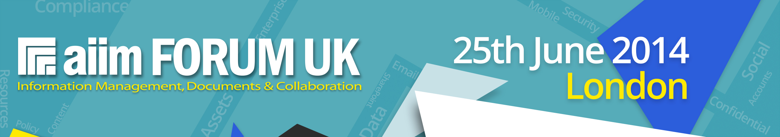

Shipping Instructions
AIIM Forum UK

Send all materials to:
AIIM Forum UK
FAO: Eli Tomkinson, Revolution Events
Adriana Rusu, ILEC Conference Centre
ILEC Conference Centre and Ibis Earls Court
London Conference Suite
47 Lillie Road
London
SW6 1UD

- Mark boxes: Use the delivery note attached and mark boxes “AIIM Forum UK.”
- Mark the name of organisation on each box (not just the delivery company).
- DO NOT ship boxes to arrive before Tuesday 24 June, as the venue will not accept them.
- IMPORTANT: If your boxes need to arrive before Tuesday 24 June special arrangements must be made. Call +44 (0)1892 820 940 or email eli@revolution-events.com to organise this.
- We are expecting a total of around 300 attendees so if you are sending literature we suggest a maximum of 300 copies should be sent.

HOT LINES FOR TROUBLESHOOTING

Eli Tomkinson
Tel (before 17.30 Monday 23 June): +44 (0)1892 820 940
Email: eli@revolution-events.com

Thank you for your support of the AIIM Forum UK

AIIM Forum UK
ILEC Conference Centre and Ibis Earls Court
London Conference Suite
47 Lillie Road
London
SW6 1UD

FAO: Eli Tomkinson / Adriana Rusu
Sender:
Company:
Stand Number:
No of Boxes:

______ of _______

